“Gender Ideology” and Religion
ex æquo n.º 37

CALL FOR PAPERS

Dossier: “Gender Ideology” and Religion
Coordinated by:
Teresa Toldy – Universidade Fernando Pessoa, Porto/Centro de Estudos Sociais da Universidade de Coimbra, Portugal.
Fernanda Henriques – Labcom.IFP/Núcleo da Universidade de Évora/Professora Emérita da Universidade de Évora, Portugal.
Carmen Bernabé – Universidad de Deusto

Deadline: 30 November (for publication in May 2018)

The category of “gender” has been controversial since the inception of its usage. This is true for the framework more directly connected to feminist activisms, as well as in the context of anti-feminist activism. The conflict over interpretations concerning the validity or adverse character of the category “gender” is also visible in the academic context, with some classifying it as an indispensable analytic category for feminist studies while others consider it an obstacle for the development of the field. Gender theorists themselves have different perspectives over the meaning and opportunity of this category (Braidotti, 2004; Butler 1990; Butler et al. 2007; Scott 2010).
From 2013 onwards, however, the expression “gender ideology” has most frequently been reused by discourses of the Catholic Church, not only denoting a negative perspective over a feminised human nature, dangerous to women, but also, to a certain extent, contrary to a “sound” Christian outlook. This view implies that gender is a category without controversy, ignoring the wide range of perspectives it encompasses (Favier 2012; Ruether 2008).
These discourses hence appear to highlight a lack of knowledge as regards the controversial theories over the issue of a feminised human nature as well as the concept of gender. Simultaneously, they themselves reveal a “gender ideology”, that is, the discourse of the official documents of the Catholic Church is itself indicative of an ideological position of power as regards women – a socially constructed perspective that sees itself as corresponding to a “female essence”, defined in accordance with an unchangeable and transcendent design (Graff 2016; Bracke 2016; Perintfalvi 2016).
This position of the Catholic Church has surpassed the remit of the religious and confessional, having been disseminated not only by the documents of the Vatican and the Episcopal Conferences of various countries, but also by groups which have actively promoted the “critique of gender ideology” (identified as the recognition that gender is a social construction of sex), with interference in the education sector (see, for instance “Do not mess with my kids: No to gender ideology”. Available at https://www.dejusticia.org/en/do-not-mess-with-my-kids-no-to-gender-ideology/).
It is important, for the reasons enunciated, to show the fraudulent character which serves as the foundation of the expression “gender ideology”. This is all the more so because the treatment of gender issues has acquired increased relevance in the context of feminist movements of various religions, namely those that are monotheistic.
Positing that, even in secular States, religious symbologies play a crucial role in the establishment of a symmetrical anthropological representation between women and men (Toldy 2010; Henriques 2011; Henriques e Toldy 2012; Toldy e Santos 2014), the problematics of gender indeed deserves to be addressed from the standpoint of religious discourse.

This issue of Revista ex aequo seeks article proposals that may contribute to:
- clarify the expression “gender ideology”, deconstructing the presuppositions that provide the foundations for the use of the expression “gender ideology”;
- construct the conceptual framework that handles the category of “gender” from different perspectives;
- critically intersect issues of “gender” with those of the position of the Catholic Church over gender;
- critically present policies or currently existing initiatives aiming towards a “depoliticisation of schools”, focusing on the eradication of “gender ideology”

Bibliographical References
Bracke, Sarah. 2016. “Unpacking the Sin of Gender”. Religion and Gender 6(2), pp. 143–154.
Braidotti, Rosi 2004. Feminismo, diferencia sexual y subjetividad nómade. Barcelona: Gedisa,.
Butler, Judith. 1990. Gender Trouble: Feminism and the Subversion of Identity. New York: Routledge.
Butler, Judith et al. 2007. « Pour ne pas en finir avec le ‘genre ‘... Table ronde », Sociétés & Représentations 24, pp. 285-306. DOI 10.3917/sr.024.0285
Favier, Anthony. 29 Sept. 2012. “La reception catholique des etudes de genre: une approche historique.” Le genre, approches depassionnees d’un debat. Lille. Available at: http://halshs.archives-ouvertes.fr/docs/00/76/57/86/PDF/RA_ ception_catholique_du_genre.pdf. Fou (accessed at 22 June 2017).
Graff, Agnieszka. 2016. “‘Gender Ideology’: Weak Concepts, Powerful Politics”. Religion and Gender 6(2), pp. 264–272.
Henriques, Fernanda 2011. “Teologia e Feminismo”, in E Deus criou a Mulher. Mulheres e teologia, coord. por Anselmo Borges e Isabel Caldeira, pp. 13-33. Coimbra: Nova Delphi.
Henriques, Fernanda; Toldy, Teresa. 2012.“A conceção inferior do feminino como ‘entidade transparente’ na Filosofia e na Teologia”, in Mulheres que ousaram ficar. Contributos para a Teologia feminista, edited by F. Henriques, T. Toldy, Maria Carlos Ramos, Julieta Dias, 121-164. Leça da Palmeira: Letras e Coisas.
Perintfalvi, Rita. 2016. “The True Face of the ‘Gender Ideology’ Discourse: Religious Fundamentalism, or Questioning the Principle of Democracy?” Journal of the European Society of Women in Theological Research, 24, pp. 47-62.
Ruether, Rosemary Radford. 2008. Catholics Does Not Equal the Vatican: A Vision for Progressive Catholicism. New York: New Press.
Scott, Joan Wallach 2010. “Gender: Still a Useful Category of Analysis?” Diogenes 57(1), pp. 7-14 (http://journals.sagepub.com/doi/pdf/10.1177/0392192110369316)
Toldy, Teresa. 2010. "A violência e o poder da(s) palavra(s): a religião cristã e as mulheres", Revista Crítica de Ciências Sociais, 89, pp. 171-183.
Toldy, Teresa; Santos, Ana Cristina. 2016. "Religião, género e cidadania sexual: Uma introdução". Revista Crítica de Ciências Sociais, 110, pp. 43-50.

Deadline and guidelines for submission
All submissions have to abide by the publication guidelines of ex æquo, which are available at http://www.apem-estudos.org/en/page/apresentacao-da-revista, and the papers should be sent until 30 of November, to the e-mail apem1991@gmail.com. The submissions that do not abide by the publication guidelines of ex æquo (e.g. references, tables and figures, article length) will be immediately excluded from the arbitrage process. Within four weeks after submission, the authors will receive an email informing of the decision to send the paper for peer review or the exclusion from the arbitrage process. The date due for publication of this special number is May 2018

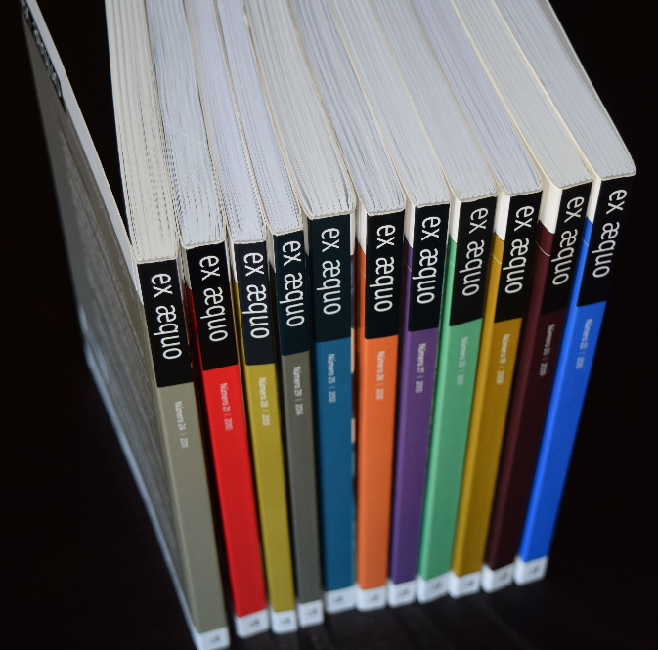
The call for non-themed submissions (articles and reviews) is continuously open.

ex æquo
is a scientific, interdisciplinary and multidisciplinary peer reviewed journal open to contributions of multiple disciplines and currents of thought. Published since 1999 as a bi-annual interdisciplinary journal in the area of Women’s, Gender and Feminist Studies (http://exaequo.apem-estudos.org/page/apresentacao-da-revista?lingua=en)
ex æquo invites submissions of original papers, both to the thematic dossiers and the studies and essays caption, and book reviews. The Journal is edited by the Portuguese Association of Women’s Studies (APEM) and is directed to an international audience, accepting manuscripts submitted in Portuguese, English, French and Spanish, from various countries. It aims to ensure that the articles published make a significant contribution to the advance of knowledge. Articles submitted for publication undergo a blind independent review by at least two recognised specialists drawn from a range of countries.
It is sponsored by the Portuguese Foundation for Science and Technology (FCT) (http://alfa.fct.mctes.pt/apoios/facc/estatisticas/periodicos_2002_2006#sociais).
Indexed in:
SciELO Citation Index da Thomson Reuters: SciELO Citation Index - http://apps.webofknowledge.com/SCIELO ;
SciELO/Portugal – Scientific Eletronic Library Online, since 2008: http://www.scielo.mec.pt/scielo.php?script=sci_serial&pid=0874-5560&lng=pt ;
Catálogo Latindex – Sistema Regional de Información en Línea para Revistas Científicas de América Latina, el Caribe, España y Portugal: http://www.latindex.unam.mx/latindex/ficha?folio=14734 ;
ERIH PLUS (European Reference Index for the Humanities): https://dbh.nsd.uib.no/publiseringskanaler/erihplus/periodical/info?id=482587.
Please, check all the information about the journal in our website:
http://exaequo.apem-estudos.org/page/numeros-publicados?lingua=en

