CALL FOR PAPERS  Women in the colonial periodical press:  discourses and representations  Coordination: Jessica Falconi (CEsA-ULisboa)  Doris Wieser (CEC-FLUL)  SUBMISSION – 30 NOVEMBER 2018  (to be published in June 2019) | Application Accepted:  Already Indexed:  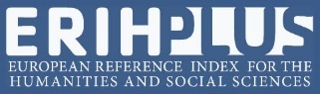  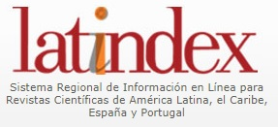
This dossier intends to focus on the presence of women in the periodical colonial press, understood as a multiform and multi-located archive which includes both the periodicals published in the former Portuguese colonies and those published in the metropolis on colonial themes. It is an archive that produces a ‘discourse network’ (Helgesson, 2011) and ‘co-histories’ (Codell, 2003), but also silences and omissions that still need to be highlighted. In the context of cultural memory studies, the concept of ‘archive’ translates into ‘storage memory’. For Assmann (2011), the storage contains forgotten elements of history which are not used at a given moment but constitute a reservoir of knowledge that can be harnessed for a change or renewal of the current ‘functional memory’, which is conditioned by the existing structures of power. In this sense, we want to question the extent to which the study of the presence of women in the colonial periodical press can contribute to the creation of a diversified, more inclusive or even counterhegemonic ‘functional memory’. Our aim also consists in questioning, in this archive, the opacity of the concept of ‘women’ as a unitary sociological subject, especially when it is applied to the colonial context, where differences in class, race and ethnicity markedly represent political and ideological representations, discourses and positions (Midgley, 1998; Levine, 2004).

As for the participation of women in the periodical press within the space that was considered the Portuguese empire, the existing studies have focused mainly on the literary collaboration of prominent voices of the lusophone literatures emerged in the colonial times (Owen, 2007, Mendonça, 1989). However, the collaboration of women in the so-called ‘Feminine Pages’ or ‘Women's Pages’, as well as in other areas and matters, remains to be explored in a more systematic way. In these pages the categories gender, class and race, the ideas of civilization and modernity (Havstad, 2016) as well as local and/or national traditions and values are negotiated within various topics. Some of these topics are traditionally associated with the ‘feminine’ world: literature, education, hygiene, domestic care, cooking, fashion, etc. Besides, these pages negotiate reproductions and/or contestations of the colonial discourse, producing ambivalent positions and both individual and collective narratives.

Some of the relevant topics are related to the following questions: What role did the colonial press confer to women as active collaborators and how were domestic, economic, political and intellectual activities evaluated by women? Which places were reserved for them and which were difficult to access? Given that a significant part of the collaboration in the colonial press came from middle-class white women, how was the ‘white woman's burden’ equated (Burton, 1990) and how were the different racialized constructions of women represented?

Through case studies or broader reflections, we intend to place the analysis of the presence of women in the periodical colonial press in an area of intersection between the studies on colonialism and gender and women’s studies. In addition, and given the scarcity of studies carried out so far on women in the colonial press of the former Portuguese empire (Havstad 2016; Owen 2007), the dossier also aims to stimulate comparative approaches with studies on women in the colonial press of other linguistic contexts such as English-speaking, French-speaking or Hispanic. May the attached bibliography serve as a first source of inspiration or support in this regard.
Références
Assmann, Aleida. 2011. Cultural Memory and Western Civilization: Functions, Media, Archives. Cambridge: Cambridge University Press.
Burton, Antoinette M. 1990. “The white woman's burden: British feminists and the Indian woman, 1865–1915”. Women's Studies International Forum (13: 4): 295-308.
Codell, Julie F., org. 2003. Imperial Co-histories: National Identities and the British and Colonial Press. Madison and Teaneck, NJ: Fairleigh Dickinson University Press; London: Associated University Press.
Brown, Megan. 2006. “A Literary Fortune: Mary Fortune's Life in the Colonial Periodical Press”. In The Unsociable Sociability of Women's Lifewriting, organizado por Anne Collett e Louise D'Arcens, 128-147. New York: Palgrave Macmillan.
García López, Ana Belén. 2011. “La participación de las mujeres en la independencia hispanoamericana a través de los medios de comunicación”. Historia y Comunicación Social (16): 33-49.
Havstad, Lilly. 2016. “Multiracial Women and the African Press in Post-World War II Lourenço Marques, Mozambique”, South African Historical Journal (68:3): 216, 390-414.
Helgesson, Stefan. 2011. Transnationalism in Southern African Literature: Modernists, Realists, and the Inequality of Print Culture. New York: Routledge.
Holdridge, Christopher. 2010. “Circulating the African Journal: The Colonial Press and Trans-Imperial Britishness in the Mid Nineteenth-Century Cape”. South African Historical Journal (62:3): 487-513.
Levine, Philippa, org. 2004. Gender and Empire. Oxford: Oxford University Press.
Mendonça, Fátima. 1989. Literatura moçambicana: a história e as escritas. Maputo: Universidade Eduardo Mondlane.
Meléndez, Mariselle. 2002. “Representing Gender, Deviance, and Heterogeneity in the Eighteenth‐Century Peruvian Newspaper Mercurio Peruano”, In Colonialism Past and Present: The Politics of Reading and Writing about Colonial Latin American Texts Today, organizado por Alvaro Félix Bolaños e Gustavo Verdesio, 175‐195. New York: SUNY University Press, 2002.
Midgley, Claire, org. 1998. Gender and Imperialism. Manchester: Manchester University Press.
Owen, Hilary. 2007. Mother Africa, Father Marx: Women’s Writing of Mozambique 1948–2002. Lewisburg: Bucknell University Press.
Pereda, Alicia. 2003. “De las ‘damas melindrosas’ a las ‘señoritas amables’: las mujeres en la prensa mexicana a comienzos del siglo XIX”, Cuadernos americanos (100): 160‐180.
Poupeney Hart, Catherine. 2010. “Prensa periódica y letras coloniales”, Tinkuy 14.
Quirk, Denise P. 2003. “‘True Englishwomen’ and ‘Anglo-Indians’: Gender, National Identity, and Feminism in the Victorian Women's Periodical Press”. In: Imperial co-histories: national identities and the British and colonial press organizado por Julie F. Codell, 167-187. Madison, N.J.: Fairleigh Dickinson University Press.
Deadline and guidelines for submission
All submissions have to abide by the publication guidelines of ex æquo, which are available at http://www.apem-estudos.org/en/page/apresentacao-da-revista, and the papers should be sent until 30 of November 2018, to the e-mail apem1991@gmail.com. The submissions that do not abide by the publication guidelines of ex æquo (e.g. references, tables and figures, article length) will be immediately excluded from the arbitrage process. Within four weeks after submission, the authors will receive an email informing of the decision to send the paper for peer review or the exclusion from the arbitrage process. The date due for publication of this special number is June 2019.

The call for non-themed submissions (articles and reviews) is continuously open.

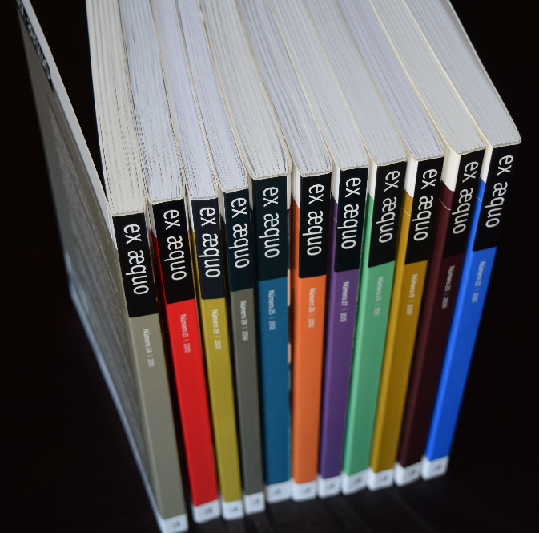
ex æquo
ex æquo is a scientific, interdisciplinary and multidisciplinary peer reviewed journal open to contributions of multiple disciplines and currents of thought. Published since 1999 as a bi-annual interdisciplinary journal in the area of Women’s, Gender and Feminist Studies (http://exaequo.apem-estudos.org/page/apresentacao-da-revista?lingua=en)
ex æquo invites submissions of original papers, both to the thematic dossiers and the studies and essays caption, and book reviews. The Journal is edited by the Portuguese Association of Women’s Studies (APEM) and is directed to an international audience, accepting manuscripts submitted in Portuguese, English, French and Spanish, from various countries. It aims to ensure that the articles published make a significant contribution to the advance of knowledge. Articles submitted for publication undergo a blind independent review by at least two recognised specialists drawn from a range of countries.
It is sponsored by the Portuguese Foundation for Science and Technology (FCT) (http://alfa.fct.mctes.pt/apoios/facc/estatisticas/periodicos_2002_2006#sociais).

